A

Mini-Project Report on

# AI POWERED CAREER CATALYST

Submitted in partial fulfilment of the requirements for the degree of

BACHELOR OF ENGINEERING

IN

**Computer Science & Engineering** Artificial Intelligence & Machine Learning by

Vaibhav Bura (22106067)

Vivek Dalvi (22106108)

Yash Desai (22106005)

Pratik Dhas (22106063)

Under the guidance of

# Prof. Vijesh Nair



**Department of Computer Science & Engineering**

**(Artificial Intelligence & Machine Learning)**

**A. P. Shah Institute of Technology**

**G. B. Road, Kasarvadavali, Thane (W)-400615**

**University Of Mumbai 2023-2024**

# A. P. SHAH INSTITUTE OF TECHNOLOGY



## CERTIFICATE

This is to certify that the project entitled “**AI POWERED CAREER CATALYST”** is a bonafide work of Vaibhav Bura (22106067), Vivek Dalvi (22106108), Yash Desai (22106005), Pratik Dhas (22106063) submitted to the University of Mumbai in partial fulfilment of the requirement for the award of **Bachelor of Engineering** in **Computer Science & Engineering (Artificial Intelligence & Machine Learning).**

|  |  |
| --- | --- |
| ________________ | _______________ |
| Prof. Vijesh Nair | Dr. Jaya Gupta |
| Mini Project Guide | Head of Department |
|  |  |

# A. P. SHAH INSTITUTE OF TECHNOLOGY



## Project Report Approval

This Mini project report entitled “**AI POWERED CAREER CATALYST*”*** by Vaiibhav Bura, Vivek Dalvi, Yash Desai and Pratik Dhas is approved for the degree of ***Bachelor of Engineering*** in ***Computer Science &Engineering***, (AIML) ***2023-24***.

External Examiner:

Internal Examiner:

Place: APSIT, Thane Date:

**Declaration**

We declare that this written submission represents my ideas in my own words and where others' ideas or words have been included, I have adequately cited and referenced the original sources. I also declare that I have adhered to all principles of academic honesty and integrity and have not misrepresented or fabricated or falsified any idea/data/fact/source in my submission. I understand that any violation of the above will be cause for disciplinary action by the Institute and can also evoke penal action from the sources which have thus not been properly cited or from whom proper permission has not been taken when needed.

Vaibhav Bura Vivek Dalvi Yash Desai Pratik Dhas

(22106067) (22106108) (22106005) (22106063)

### ABSTRACT

The AI-powered career catalyst offers a transformative solution in the evolving landscape of job application processes by leveraging artificial intelligence (AI) to streamline and enhance resume creation. Utilizing advanced natural language processing (NLP) algorithms, this innovative system analyses individual career trajectories, skills, and achievements to produce up-to-date and tailored resumes that align with specific roles. Its machine learning capabilities enable adaptation to changing industry trends and job market demands, while key features such as automated content generation, intelligent keyword optimization, and personalized formatting suggestions help users create compelling resumes that stand out to potential employers. The platform also assists in identifying employment history gaps, suggesting relevant skills enhancement opportunities, and recommending industry-specific keywords to enhance visibility in applicant tracking systems (ATS). Designed with a user-friendly interface for accessibility across varying technological proficiencies, the system fosters inclusivity in the job-seeking process and respects user privacy through stringent data protection protocols and user-controlled information sharing. As organizations increasingly recognize the value of AI in talent acquisition, the AI-powered career catalyst emerges as a valuable tool, saving time for both job seekers and employers and reshaping the future of resume creation and job application processes.Top of Form

## Index

|  |  |  |  |
| --- | --- | --- | --- |
| Index | | | Page no. |
| Chapter-1 | | | 1-2 |
|  | Introduction | | 2 |
|  |  |  |  |
| Chapter-2 | | | 3-5 |
|  | Literature Survey | |  |
|  | 2.1 | History | 4 |
|  | 2.1 | Review | 5 |
|  |  |  |  |
| Chapter-3 | | | 6-7 |
|  | Problem Statement | | 7 |
|  |  |  |  |
| Chapter-4 | | | 8-9 |
|  | Experimental Setup | |  |
|  | 4.1 | Hardware setup | 9 |
|  | 4.2 | Software Setup | 9 |
|  |  |  |  |
| Chapter-5 | | | 11-14 |
|  | Proposed system and Implementation | |  |
|  | 5.1 | Block Diagram of proposed system | 11 |
|  | 5.2 | Description of Block diagram | 12 |
|  | 5.3 | Implementation | 13-14 |
|  |  |  |  |
| Chapter-6 | | | 15 |
|  | Conclusion | | 16 |
|  |  |  |  |
| References | | | 17 |
|  |  |  |  |

**CHAPTER 1**

**INTRODUCTION**

1

### INTRODUCTION

In the dynamic landscape of modern employment, where opportunities arise and fade with unprecedented speed, the significance of a well-crafted resume cannot be overstated. The traditional approach to resume creation, however, often proves time-consuming and may not align optimally with the evolving demands of various industries. To address this challenge, artificial intelligence (AI) has emerged as a catalyst for transformative innovation, giving rise to the AI-powered career catalyst.

This groundbreaking technology signifies a paradigm shift in how individuals present their professional narratives to potential employers. Leveraging the prowess of AI, this career catalyst offers an intelligent and adaptive solution, revolutionizing the way resumes are crafted, optimized, and tailored for diverse job opportunities.

In this era of information abundance, where the volume of job applicants can overwhelm recruitment processes, the AI-powered resume generator becomes a strategic tool for job seekers to navigate the competitive landscape. By harnessing advanced natural language processing (NLP) and machine learning algorithms, this system empowers users to create compelling resumes that not only reflect their unique skills and experiences but also align seamlessly with the specific requirements of their target roles.

This introduction sets the stage for exploring the multifaceted capabilities of the AI-powered career catalyst, highlighting its potential to enhance the efficiency, effectiveness, and personalization of the job application process. As we delve deeper into the functionalities and benefits of this innovative technology, it becomes evident that the fusion of AI and resume creation is poised to redefine the way individuals showcase their professional identities in the pursuit of fulfilling and meaningful career opportunities.

2

# CHAPTER 2

**LITERATURE SURVEY**

3

## LITERATURE SURVEY

**2.1-HISTORY**

|  |
| --- |
| The history of AI-powered career catalyst can be traced back to the late 20th century when the advent of computer technology began influencing various aspects of human life, including employment processes. Early attempts at automating resume creation involved basic keyword matching algorithms to optimize resumes for applicant tracking systems (ATS).  In the mid-2000s, with the rise of machine learning and natural language processing (NLP) technologies, the capabilities of career catalyst evolved significantly. These systems started to analyse and understand the context of information, enabling a more sophisticated approach to resume customization.  The last decade witnessed a surge in AI-powered resume generators, fueled by advancements in deep learning and neural networks. These technologies allowed for a more nuanced understanding of individual career trajectories, skills, and industry trends. The generators became capable of providing personalized formatting suggestions, recommending relevant keywords, and adapting to changing job market dynamics.  Today’s AI-powered career catalyst leverage state-of-the-art NLP models and machine learning algorithms, offering users an intelligent and user-friendly interface. These systems not only automate the process of resume creation but also provide valuable insights, helping individuals tailor their resumes for specific roles and stay competitive in a rapidly evolving job market. The ongoing integration of AI technologies continues to shape the future of career catalyst, promising further advancements in efficiency and personalization for job seekers worldwide.  Top of Form  4 |

## 2.2-LITERATURE REVIEW

**Information Should Be Included in The Resume**

Job applicants have the flexibility to choose from various resume categories, including personal information, personal opening, education, work experience, references, scholarships and awards, hobbies and interests, and willingness to relocate and travel. Empirical research suggests including the applicant's name, address, and phone number in the personal information section, with recent studies recommending a school email address for students and graduates. While recent research questions the need for a personal opening, a job or career objective has traditionally been deemed important. A summary of qualifications may also be valuable, but further research is needed to assess its effectiveness alongside a career or job objective. Currently, resume creation is largely manual, requiring significant manpower for tasks that could be automated. Historically, resumes were handwritten and formatted differently, with candidates typically including their name, address, and phone number.

In the past, applicants would include their personal opinions in their resumes. Applicants used to give both their early and recent educational details at that time. Because there were no guidelines defined for the appropriate length of resumes at the time, applicants used to create either too short or too long resumes. Our proposed solution automates the resume-building process. This technology allows for online storing, updating, and retrieval. Customers and viewers/employers can benefit from this system. Everything is stored electronically in this system, so there is a lot less paperwork and information can be obtained quickly without having to dig through registers. Certain aspects of our system are not available in the current manual system. They are a planned approach to working, reliability, no redundancy, immediate information retrieval, and ease of use. What conclusions may be taken from literature analysis and research on the length of a resume? In a CV, what information should be included? When drafting a resume, what information should be avoided? Name, address, phone number, and email address should be included in personal information, but height, weight, religion, birth date, and marital status should be omitted. Resumes that are one page long are preferred over resumes that are two pages long.

5

**CHAPTER 3**

**Problem Statement**

**6**

**3.1 Problem Statement**

|  |
| --- |
| In the contemporary job market, the recruitment process is often time-consuming and resource-intensive for both employers and job seekers. Traditional methods of resume creation and screening can be subjective, leading to potential oversights and inefficiencies. To address these challenges, there is a critical need for an AI-powered career catalyst that leverages advanced machine learning algorithms to streamline the resume creation process, enhance candidate profiling, and facilitate more accurate and efficient recruitment. |

7

# CHAPTER 4

# Experimental Setup

8

**4.1 HARDWARE SETUP**

**Computer:** Users will access the website from various devices such as desktop computers, laptops, tablets, and smartphones.

**Memory (RAM):** Ample RAM is crucial for handling large datasets during training and for efficiently processing user requests during runtime.

**Storage:** Large-scale storage solutions, such as Network Attached Storage (NAS) or cloud storage, are essential for storing extensive datasets, pre-trained models, and user data.

## 4.2 SOFTWARE SETUP

1. **Operating System:** Linux-based operating systems, such as Ubuntu or CentOS, are commonly used for their stability, security, and compatibility with many AI frameworks.
2. **Database Management System:** A relational or NoSQL database (e.g., PostgreSQL, MongoDB) is needed for storing user profiles, resumes, and other relevant data.
3. **API:** Chatbot API (Messaging)
4. **Programming Languages and Frameworks:**

**\*Frontend**: HTML and CSS are used for the user interface to make the frontend look more attractive.

**Backend:** PHP and My SQL, JavaScript, Python.

9

**CHAPTER 5**

**Proposed system and Implementation**

10

**5.1 Block diagram of proposed system**

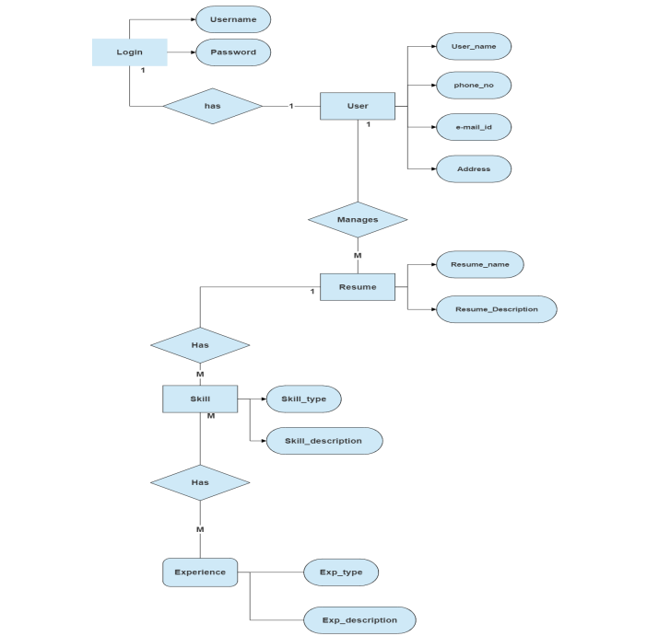

11

**5.2 Description of block diagram**

* **Username:** This block represents the field where a user enters their username or email address to identify themselves to the system.
* **Password:** This block represents the field where a user enters their password to authenticate their identity.
* **Login:** This block represents the button or action a user takes to submit their login credentials. When a user clicks login, the system validates the username and password against the User database.
* **User Database:** This block represents the database that stores user information, including usernames, passwords, and potentially other user data like contact information or preferences.
* **Success:** If the username and password match an entry in the User database, the login is successful. What happens next depends on the system design, but typically, the user would be granted access to the system's features or functionalities.
* **User name:** This line likely indicates that upon successful login, the system retrieves the user's name from the User database.
* **Failure:** If the username and password don't match an entry in the User database, the login is unsuccessful. The system typically provides feedback to the user, such as an error message indicating invalid credentials.
* **Phone no.** This block represents a field where a user might enter their phone number during the registration process. It likely connects to the User database block.
* **Address** This block represents a field where a user might enter their address during the registration process. It likely connects to the User database block.
* **Resume** This block represents a section where a user might upload their resume during the registration process. It likely connects to the User database block.
* **Skill** This block represents a section where a user might enter their skills during the registration process. It likely connects to the User database block.
* **Experience** This block represents a section where a user might enter their work experience during the registration process. It likely connects to the User database block.

12

**5.3 Implementation**

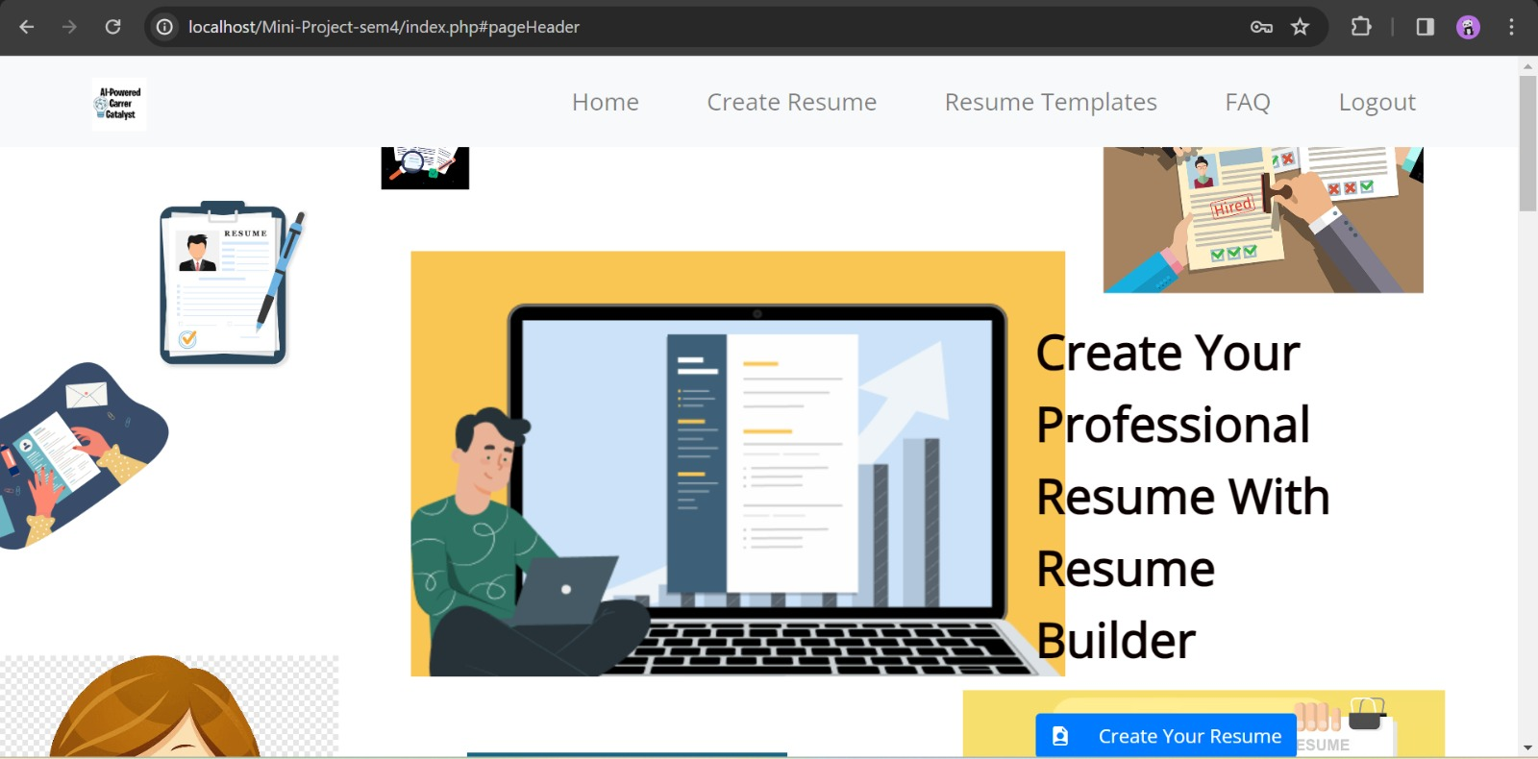

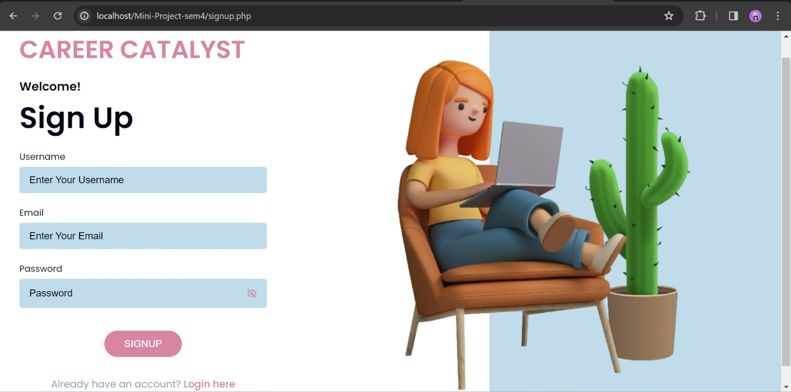

13

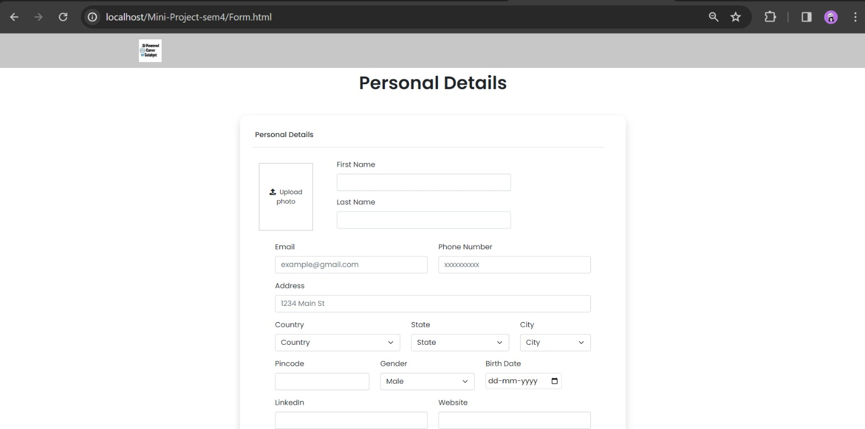

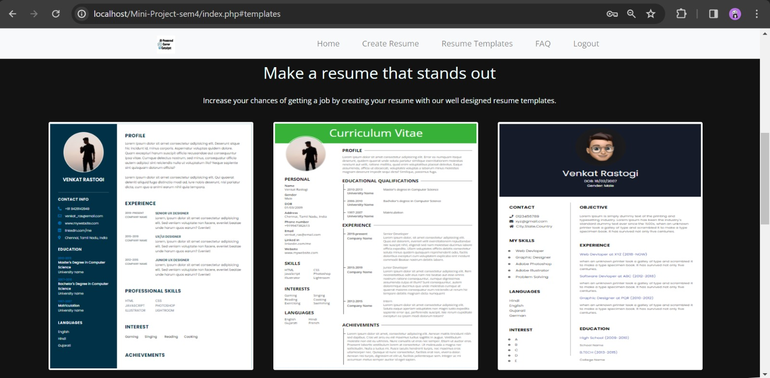

14

**CHAPTER 6**

**Conclusion**

15

**Conclusion**

This project explored the development of an AI-powered career catalyst tool. The tool leverages artificial intelligence to guide users through the career development process, from self-assessment and goal setting to job search assistance and interview preparation. By utilizing AI for personalized recommendations, skill gap analysis, and targeted job market information, the career catalyst empowers users to make informed decisions and take proactive steps towards achieving their career aspirations.

16

**References**

1. E. Forsberg, “Curriculum Vitae – The Course of Life,” Nordic Journal of Studies in Educational Policy, 2016(2-3), 33742, 2016, doi:10.3402/nstep.v2.33742.
2. D. R. Dickson, K. Nusair, “An HR perspective: the global hunt for talent in the digital age,” Worldwide Hospitality and Tourism Themes, 2(1), 86–93, 2010, doi:10.1108/17554211011012612.
3. C. Canibano, B. Bozeman, “Curriculum vitae method in science policy and ˜ research evaluation: the state-of-the-art,” Research Evaluation, 18(2), 86–94, 2009, doi:10.3152/095820209X441754.
4. R. Woolley, T. Turpin, “CV analysis as a complementary methodological approach: investigating the mobility of Australian scientists,” Research Evaluation, 18(2), 143–151, 2009, doi:10.3152/095820209X441808.

17